SIR APOLLO KAGGWA SCHOOLS
MID TERM II - 2024
PRIMARY TWO
ENGLISH

My name is ________________________________________________
School _____________________________________________________

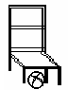
1. Name these objects.
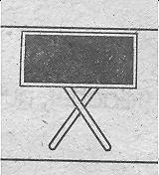
(a) ________________ (b) _____________
a b c d e f g h

(c) __________________

2. Make small words from the big ones.
(a) teacher _______________
(b) uniform _______________
(c) handkerchief ______________

3. Arrange these words in alphabetical order.
(a) flag, badge, motto, signpost
___________________________________________________
(b) rubber, pencil, book, desk
___________________________________________________

4. Use the plural of the word given in the brackets.
(a) He carried the ______________ to the church. (box)
(b) ______________ feed on milk. (puppy)
(c) I saw two _______________ in the zoo. (ox)
(d) The man sharpened all the ______________ (knife)

5. Write these abbreviations in full.
(a) didn’t _____________ (c) Oct. _______________
(b) Tr. _____________

6. Use a or an in the gap correctly.
(a) Rhoda has ______ good handwriting.
(b) I saw ______ egg in a bucket.
(c) Our soccer team had _____ nice game yesterday.

7. Punctuate these sentences correctly
(a) that dress is very nice
(b) Sarahs book is in the cupboard

8. Give the opposite of each underlined word.
(a) My aunt is very busy. ____________
(b) Do you have a brother? _______________
(c) My son has not gone to school. _____________
9. Write out the compound words.
(a) Our bedroom is very clean. __________________
(b) The boy was called by the headteacher. ___________
(c) Mother bought a doormat and a basket yesterday. ________________

10. Use the correct form of the verb in brackets
(a) The doctor ______________ sick people everyday. (treat)
(b) She is _______________ some food now. (cook)
(c) The cat ________________ the tree yesterday. (climb)

11. Write one word for the group of words.
(a) shirt, dress, trouser and others we wear are __________
(b) a, b, c, d, e, f, g, h … are _______________
(c) lion, buffalo, dog, goat are ______________

12. Complete the table below correctly.
 | short | shorter | shortest
(a) | young | ______________ | youngest
(b) | happy | happier | ______________
(c) | ________________ | fatter | fattest

13. Underline the nouns in each sentence.
(a) Mary is very fat.
(b) Who was born on Saturday?
(c) I live at Kibuye.

14. Match the noun with the correct pronoun.
Noun Pronoun
Daddy They
Grace It
The tree She
John and Jane He

15. Join the sentences using “and”
(a) I like fish. I like meat.
___________________________________________________
(b) I can read. I can write.
___________________________________________________

16. Make sentences about each picture.
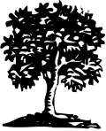

_____________________________________________
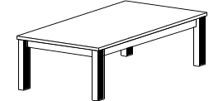
_____________________________________________

______________________________________________

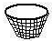

___________________________________________

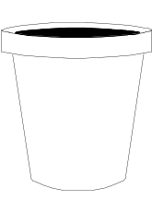
17. Answer correctly.
(a) Is this a table?
__________________________________________

(b) Are these trees?
__________________________________________

**Best wishes**
P.2 English 2024
- blackboard (b) chair (c) ruler
- (a) tea/each/teach/her
(b) form/for/if
(c) hand/chief/and
- (a) badge, flag, motto, signpost
(b) book, desk, pencil, rubber
- (a) boxes (b) Puppies
(c) oxen (d) knives
- (a) did not (b) Teacher
(c) October
- (a) a (b) an (c) a
- That dress is very nice.
(b) Sarah’s book is in the cupboard.
- (a) uncle (b) sister (c) daughter
- (a) bedroom (b) headteacher
(c) doormat
- (a) treats (b) cooking
(c) climbed
- (a) clothes (b) letters
(c) animals
- (a) younger (b) happiest
(c) fat
- (a) Mary (b) Saturday
(c) Kibuye
- Daddy – He
Grace – She
The tree – It
John and Jane - They
- (a) I like fish and meat.
(b) I can read and write.
- Mark correct sentences.
- (a) No, it is a pail.
(b) Yes, they are.

